CONEJO | ---------------------------------------------------------

GALLO  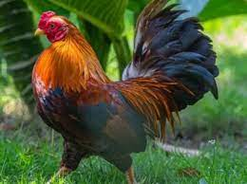 | SANTIAGO  ---------------------------------------------------------

